**Project Planning Phase**

**Project Planning Template (Product Backlog, Sprint Planning, Stories, Story points)**

|  |  |
| --- | --- |
| Date | 20 June 2025 |
| Team ID | LTVIP2025TMID49207 |
| Project Name | Measuring the Pulse of Prosperity: An Index of Economic Freedom Analysis |
| Maximum Marks | 5 Marks |

**Product Backlog, Sprint Schedule, and Estimation (4 Marks)**

Use the below template to create product backlog and sprint schedule

|  |  |  |  |  |  |
| --- | --- | --- | --- | --- | --- |
| **Sprint** | **Functional**  **Requirement**  **(Epic)** | **User Story**  **Number** | **User Story / Task** | **Story Points** | **Priority** |
| Sprint-1 | Data Analysis & Visualization | USN-1 | As a Policymaker, I want to view a world map showing economic freedom scores by country, so that I can quickly identify regions with high or low economic prosperity and potential policy impact areas. | 2 | High |
| Sprint-1 | Data Analysis & Visualization | USN-2 | As an Economic Researcher, I want to filter economic data by specific years and countries, so that I can conduct in-depth analysis on historical trends and compare performance across different nations. | 2 | High |
| Sprint-1 | Data Analysis & Visualization | USN-3 | As an Investor, I want to see the top 40 and least ranked countries based on their economic index, so that I can identify potential investment opportunities or risks in various markets. | 4 | High |
| Sprint-2 | Data Ingestion &  Management | USN-4 | As a User, I want to upload new economic datasets (e.g., CSV, Excel), so that I can incorporate the latest information into the analysis and update the index | 3 | Medium |
| Sprint-2 | Data Analysis & Visualization | USN-5 | As an Economic Researcher, I want to view correlations between economic freedom and indicators like unemployment rate and GDP growth, so that I can understand the multifaceted impacts of economic policies. | 4 | High |
| Sprint-3 | Reporting & Export | USN-6 | As a User, I want to export visualizations (e.g., charts, maps) as image files, so that I can easily include them in presentations or reports. | 4 | Medium |
| Sprint-3 | User  Management &  Authorization | USN-7 | As an Administrator, I want to manage user accounts and roles, so that I can access levels to sensitive data and functionalities. | 3 | High |

# Project Tracker, Velocity & Burndown Chart: (4 Marks)

|  |  |  |  |  |  |  |  |  |
| --- | --- | --- | --- | --- | --- | --- | --- | --- |
| **Sprint** | | **Total**  **Story**  **Points** | **Duration** | **Sprint Start Date** | **Sprint End**  **Date (Planned)** | **Story Points**  **Completed**  **(as on**  **Planned End**  **Date)** | **Sprint Release Date (Actual)** | |
| Sprint-1 | | 8 | 5 Days | 16 June  2025 | 21June 2025 | 6 | 21 June 2025 | |
| Sprint-2 | | 7 | 5 Days | 21June 2025 | 25 June 2025 | 7 | 25 June 2025 | |
| Sprint-3 | | 7 | 5 Days | 25 June  2025 | 30 June 2025 |  |  | |
|  |  |  |  |  |  |  |  |  |

**Velocity:**

Imagine we have a 10-day sprint duration, and the velocity of the team is 20 (points per sprint). Let’s calculate the team’s average velocity (AV) per iteration unit (story points per day

# AV = sprint duration/velocity =15/10=1.5

**Burndown Chart:**

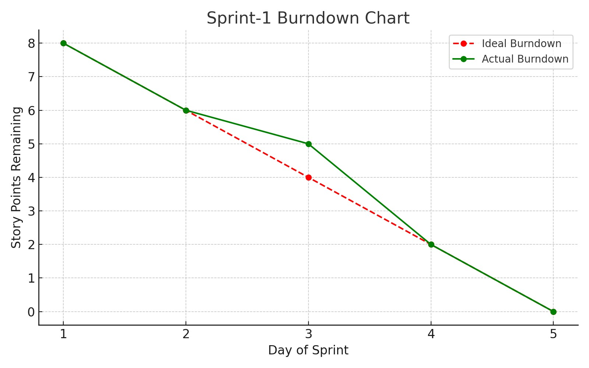

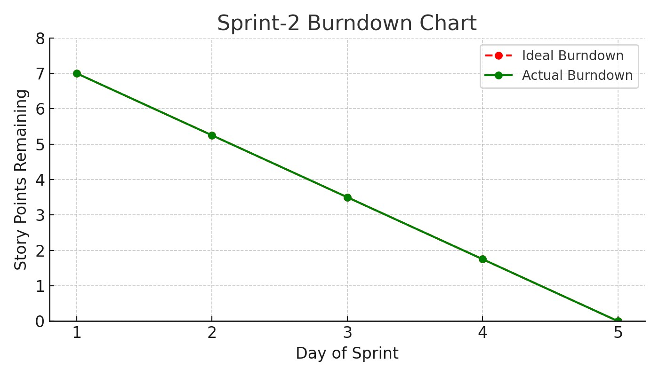

[**https://www.visual-paradigm.com/scrum/scrum-burndown-chart/**](https://www.visual-paradigm.com/scrum/scrum-burndown-chart/)

[**https://www.atlassian.com/agile/tutorials/burndow**](https://www.atlassian.com/agile/tutorials/burndown-charts)

[**n**](https://www.atlassian.com/agile/tutorials/burndown-charts)

[**-**](https://www.atlassian.com/agile/tutorials/burndown-charts)

[**chart**](https://www.atlassian.com/agile/tutorials/burndown-charts)

[**s**](https://www.atlassian.com/agile/tutorials/burndown-charts)